
Mechanical properties of formulated elastomers

Lab Report
Team M15

Che Xuanming, 2023304252
Zheng Junhao 2023304265
Zhang Yuchen 2023304212
Wang Yiming 20234232
Liu Yuming 2023304244
Dai Sibo 2023304221

1. Introduction
Over the past few decades, one of the most promising elastomers is polydimethylsiloxane (PDMS), this is a cross-linked polymer which is famous for its low Young’s modulus, high-yield strains, and the ability to restore the original shape when stress ceases [1]. The incorporation of crosslinking agents will impact the properties of PDMS. The reason is that during the preparation of Sylgard 184, the silyl group (Si-R) in Sylgard 184 is hydrolyzed with the hydroxyl group (OH) in the crosslinking agent to produce Si-O-Si bonds and alcohol molecules, and this structure helps to improve the elastic properties of PDMS[8]. In this experiment, we will specifically investigate the correlation between the Young's modulus of PDMS and the dosage of crosslinking. The tensile test is considered to be one of the most important tests in engineering. One can calculate Young's modulus and determine the elastic properties of a specimen by plotting test data on the engineering stress-strain curve.

Based on the aforementioned background, this experiment proposes the following hypothesis: It is postulated that an increase in the amount of crosslinker added will result in a corresponding elevation in Young's modulus of the product. To test this hypothesis, the experiment was divided into groups that combined equal amounts of Sylgard 184 with varying quantities of crosslinkers to produce elastomers in the shape of bones. Within each group, four samples were prepared using the same crosslinker, but these differed across distinct groups.
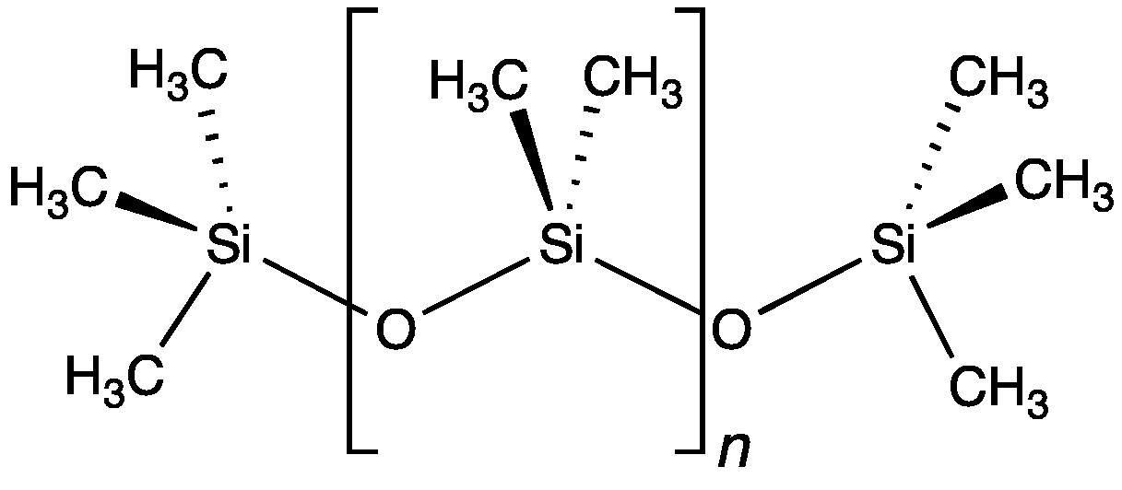
Figure 1: Structure of PDMS

2. Methods
Firstly, a pristine plastic cup was labeled with our group number and the sample code in accordance with the relevant formulation table. Afterwards, put it on the calibrated balance to measure and then 39.9916g of Sylgard and 5.0519g of crosslinker were introduced into the cup and thoroughly blended using a clean chopstick to ensure uniformity. Subsequently, the homogenized mixture was carefully poured into the designated mold until it filled all four grooves completely. Once settled within the mold, it underwent solidification through placement in a dryer, ultimately resulting in the attainment of the final sample. After the dog-bone samples were made, it was necessary to test their elastic properties. Two parallel lines of equal width were drawn on the midsection of each bone, separated by a specific distance. The distance between the lines was measured. One end of the sample was clamped and suspended, while the other end towards the ground was secured with a pre-measured clip. The weights were incrementally added, and the distance between the two lines as well as the mass of the weights were recorded after each addition until ten sets of data were obtained.
3. Results
The stress-strain graph in Fig. 2 depicts the experimental data obtained from the tensile test. By fitting a linear regression line to each model's results, we can determine the Young's Modulus based on the slope of the fitted line. The regression analysis results and corresponding errors are presented in Table 1.
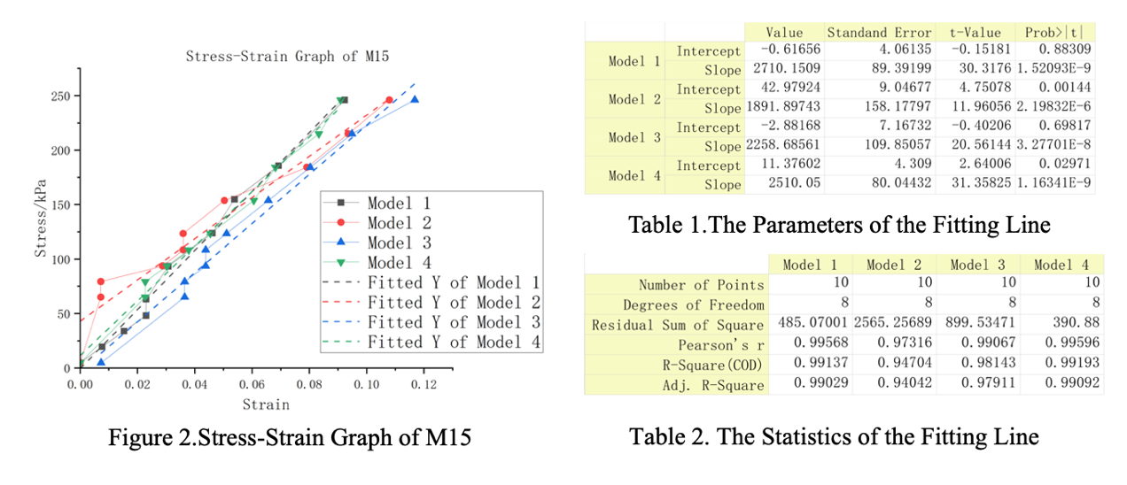

The Young's Modulus can be determined as the slope value in each model, based on the figure and table. The average Young's Modulus of the four models is 2.38MPa. Except for model 2, the error in each group is within a range of less than 4.86%. The coefficient of determination (R-square) shown in Table 2 exceeds 0.98. Model 2 exhibits a higher error compared to the other three models, with a relative error that is twice as large as that of the other models.

Group Number | Young’s Modulus/kPa
13 | 854
14 | 1327.1
15 | 2420.22
16 | 1666.1
average | 1566.855
Table 3: Young’s Modulus of different groups

Young’s Modulus of different groups is presented in Table 3. Group M13 has the lowest Young’s Modulus and group M15 has the highest. The average value of 4 groups is 1566.855MPa.

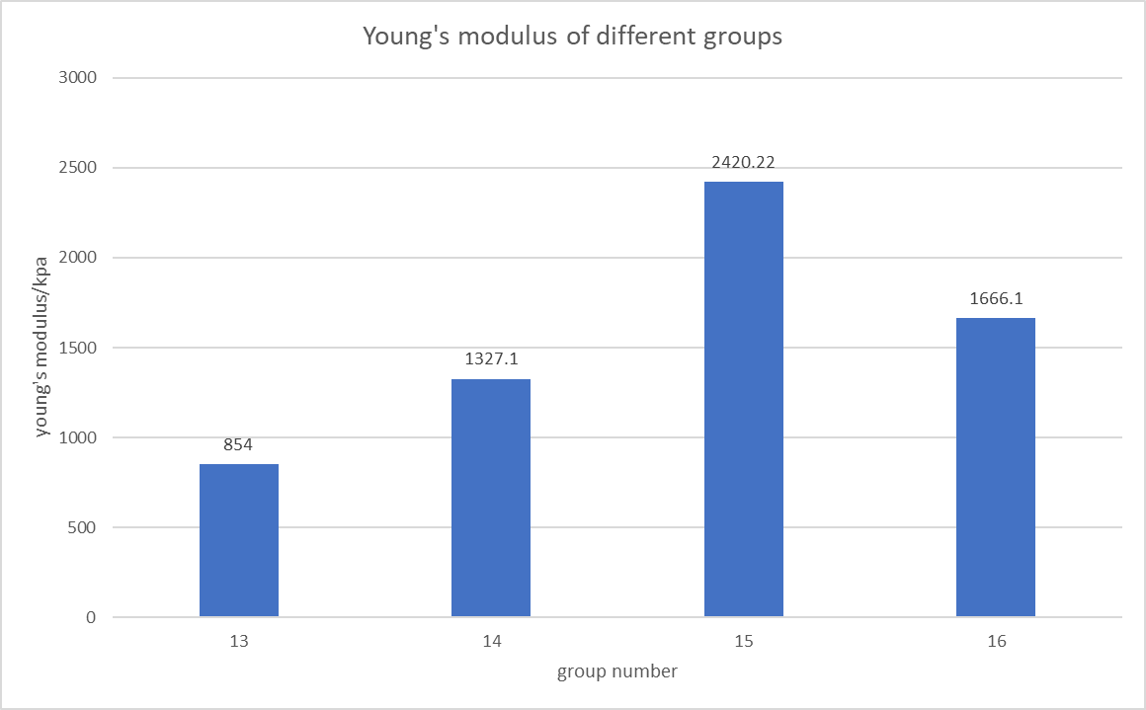
Figure 3. Young’s modulus of different groups

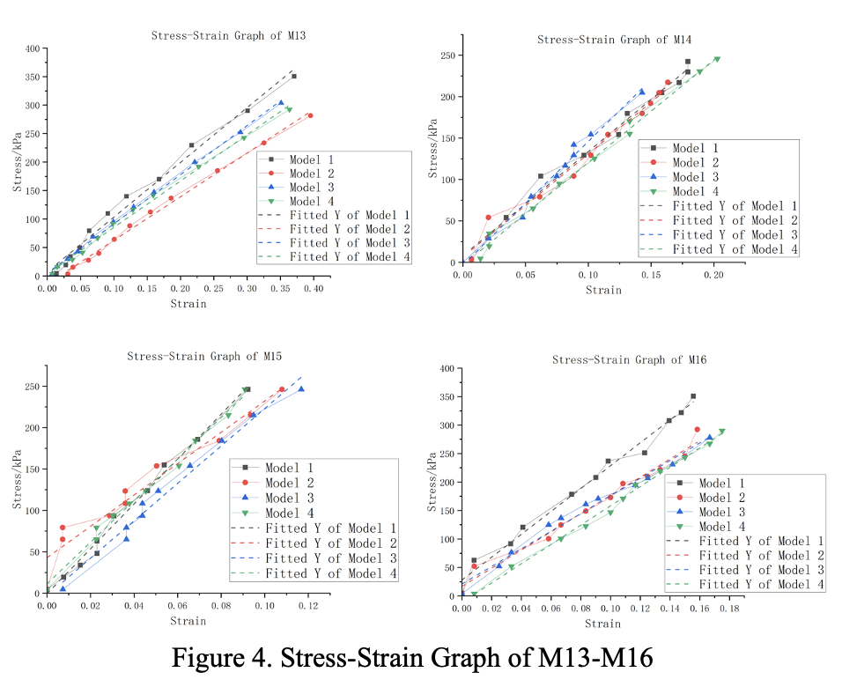
Figure 4 shows the stress-strain graphs of each group from M13 to M16. The residual sum among each model of four groups is rather small, which means stress and strain varies linearly during the tensile test. The difference between models within a group is larger than errors in a model.
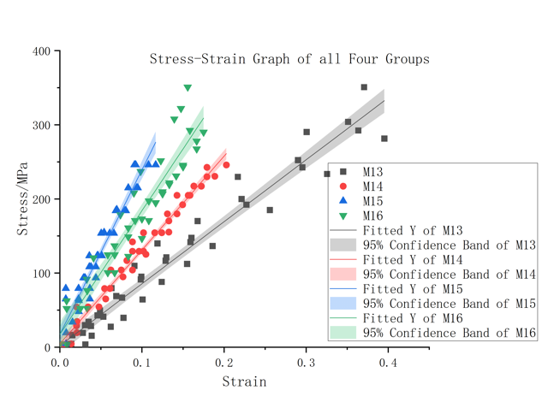
Figure 5: Stress-Strain Graph of all Four Groups

The Figure 5 is constructed by fitting a straight line to all 40 (or 44) data groups from the 4 models. This method eliminates errors between the models within each group but increases the overall error in the group. The slope of each fitted line represents the Young's modulus of each respective group. The graph reveals that M15 exhibits the highest Young's modulus, while M13 demonstrates the lowest.

4. Discussion
The experimental results have yielded the calculated value of Young's modulus, as well as the observed deformation trend with increasing weight. In the graphical representation of this trend, it is evident that the shape variable exhibits a positive correlation with weight increment, displaying a strong linear relationship supported by a calculated correlation coefficient close to unity. Upon closer examination of scattered data points, it becomes apparent that minimal changes in length occur when the mass is small; however, overall there is an irregular rise in these points indicating deviation from strict adherence to Hooke's law. The four samples in our group all adhere to the aforementioned rules, however, they exhibit distinct variations in terms of Young's modulus and deformation, thereby reflecting the disparities among the samples.

As shown in table 2 and 3, the error of a model is relatively high, especially in model 2. The errors within a model may be due to the rudimentary testing method that we used. During the tensile testing, the sample was not vertical to the ground, causing a horizontal component of force and reducing the strain applied on the model. As the weight slowly added onto the sample, the horizontal component of force changed and results in a non-linear change of strain. The second reason for the error is the error produced during the measurement by the low accuracy of the ruler and the balance. The apparatus-related component of uncertainty is 0.289mm, and when measuring a small length like the thickness of the sample, it will create a relative uncertainty of 11.55%. And the relative error contributed by the apparatuses is approximately 11.77%. This is a basic error which cannot be eliminated easily.

The Young’s modulus in four models should be same in theory, however, the error mentioned above made an aspect of the difference between models. Apart from these reasons, the differences in operation are also unneglectable. The parallel lines drawn on the sample before testing were not at the same position, so when testing, the measurements would vary and after calculating, the results and errors will not be exactly the same. Also, there would be slight difference between each model originally. If the mixture was not mixed uniformly and were not poured into the mold evenly, or if there were a slight difference of temperature when reacting, the model will have a different Young’s modulus.

It is shown in the graph and the column chart that M15 has the highest Young’s modulus and M13 has the lowest. Despite the error, the main difference between groups is the ratio of Sylgard 184 and the crosslinker. The table below shows the dosages of each raw material in each group. It indicates that the dosage of crosslinker is increasing linearly from M13 to M16, the dosage of Sylgard 184 does not change. The ratio of crosslinker and Sylgard 184 is increasing from M13 to M16. However, the Young’s modulus is increasing from M13 to M15, and decreasing from M15 to M16. In conclusion, the sample performs the highest Young’s modulus at the ratio of the crosslinker and Sylgard 184 is around 1:8. The Young’s modulus increases as the ratio increases when the ratio is under 1:8, and the Young’s modulus decreases when the ratio is greater than 1:8. Due to the insufficient number of experiments, it can only be demonstrated that Young's modulus does not exhibit a monotonic change with increasing crosslinker content. However, it can be tentatively inferred that there is an initial positive correlation followed by a negative correlation trend. According to these findings, it is postulated that a lower concentration of crosslinker leads to the formation of a grid-like structure through chemical bonding between the crosslinker and polymer chains, thereby facilitating stress dispersion and enhancing Young's modulus. Conversely, an excessive amount of crosslinking agent results in heightened stiffness and increased brittleness, consequently leading to a reduction in Young's modulus.

5. Applications
According to the Young’s modulus get from the experiments, the product and the rubbers have a Young’s modulus around 0.5-3MPa. The cross-linked PDMS would have similar mechanic properties as the rubbers like butadiene rubber, Styrene-butadiene rubber, and nitrile rubber [5]. So, the product would have similar applications that the rubbers have. It is assumed that the product would have the ability to make footwear, seals, hosing, tubing, gaskets and so on [6][7]. Due to the low Young’s modulus, the product can be used in making flex circuit boards, soft robots, and can produce microfluidic devices in lab [8].

6. Conclusions
According to the data and the graph, the shape variable of each sample in each group exhibited a positive correlation with the weight, indicating a strong linear relationship. The data presented in Figure 3 indicates that our hypothesis is incorrect. The relationship between Young's modulus and the content of crosslinker is not simply linear, but rather exhibits a positive correlation at low crosslinker contents and a negative correlation beyond a critical value. Overall, there is an initial increase followed by a subsequent decrease.

7. References
1. Soulas DN, Sanopoulou M, Papadokostaki KG. Hydrophilic modification of silicone elastomer films: Thermal, mechanical and theophylline permeability properties. Materials Science and Engineering: C. 2013 May;33(4):2122–30. doi: 10.1016/j.msec.2013.01.031
2. QXU3112 - academic and professional engineering skills - 2023/24 [Internet]. [cited 2024 Apr 8]. Available from: https://qmplus.qmul.ac.uk/course/view.php?id=22969
3. Karthikeyan R, Tjong J, Nayak SK, Sain MM. Mechanical properties and cross-linking density of short sisal fiber reinforced silicone composites. BioResources. 2016 Nov 14;12(1). doi:10.15376/biores.12.1.211-227
4. Lisa Novotny. Making Dogbone tensile test samples [Internet]. Lisa Novotny; [cited 2024 Apr 8]. Available from: https://www.testresources.net/blog/making-dogbone-tensile-test-samples
5. Young’s modulus, tensile strength and yield strength values for some materials [Internet]. 2024 [cited 2024 Apr 11]. Available from: https://www.engineeringtoolbox.com/young-modulus-d_417.html
6. Speight JG. Chapter 14 - Monomers, polymers, and plastics. In.
7. Rubber LE. What is nitrile rubber (NBR)? properties, applications, & uses [Internet]. 2024 [cited 2024 Apr 11]. Available from: https://lakeerierubber.com/what-is-nitrile-rubber-nbr-properties-applications-uses/
8. Prabowo F, Wing-Keung AL, Shen HH. Effect of curing temperature and cross-linker to pre-polymer ratio on the viscoelastic properties of a PDMS elastomer. Advanced Materials Research. 2015 Jul 10;1112:410–3. doi: 10.4028/www.scientific.net/amr.1112.410

